Muhammad Siddique
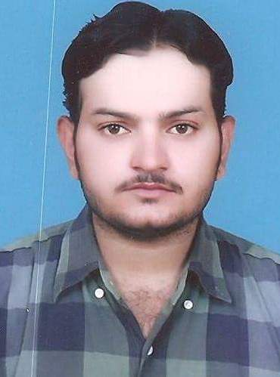
House No. 160/22 Street No. 10
Chah Korey Wala Near Bilal Motors
Multan
Cell # +92334-6116284
E-Mail:muhammadsiddiquebhatti8@gmail.com

OBJECTIVE
Motivated and detail-oriented professional transitioning into cloud computing with a strong foundation in healthcare technology, IT, and equipment handling. Eager to apply technical knowledge, problem-solving skills, and a passion for continuous learning to a dynamic cloud-based environment. Seeking an entry-level cloud computing role to grow and contribute to innovative digital solutions.
PERSONAL INFORMATION
Father's Name : Muhammad Ramzan
Date of Birth : 01-01-1986
N.I.C.No. : 36302-4461230-5
Domicile : Multan (Punjab)
Marital Status : Married
Religion : Islam
Nationality : Pakistani

QUALIFICATION

Degree | Year | Board/University
ICS | 2002 | BISE, Multan
F.A. | 2005 | BISE, Multan
BSCS | 2024 | VU, Multan
M.A (Political Science) | 2017 | BZU, Multan
OTT (operation theatre Assistant) | 2023 | PMF Lahore

SKILLS
- 1 year Training in Endoscopy Technician in Children Hospital, Multan.
- 1 Year DIT (Diploma Information Technology) GOVT College Multan.
- 8 Months Computer Operator Diploma VTI Multan.
Endoscopy Technician & CSSD Operator
Children Hospital & Chenab General Hospital, Multan — 2008 to Present
- Managed and maintained high-tech medical equipment and software systems
- Performed safety checks, troubleshooting, and calibrations
- Followed strict protocols similar to cloud security compliance standards
- Handled digital reports, records, and patient data with high accuracy
- Assisted with training and technical guidance for new staff

Relevant Skills for Cloud Computing
- Basic Cloud Concepts (IaaS, PaaS, SaaS) – Currently Learning
- Windows & Linux OS familiarity
- Excellent knowledge of IT hardware and troubleshooting
- Inventory & asset management
- Strong understanding of system safety checks
- Fast learner with high adaptability to new technologies
- Outstanding communication & team collaboration
- Problem-solving in high-pressure environments
- Comfortable working with dashboards, reports, and basic automation
- Have a strong work ethic
- Outstanding computer skills
- Result – oriented
- Quick learner
Certifications & IT Training
- Diploma in Information Technology (DIT) – Govt. College, Multan – 1 Year
- Computer Operator Diploma – VTI, Multan – 8 Months
- Hands-on Computer & Equipment Management Experience – 15+ years
(Currently exploring certifications in Cloud Computing: AWS Cloud Practitioner, Microsoft Azure Fundamentals, or Google Cloud Digital Leader)

Currently Learning
Cloud Platforms: AWS, Azure, Google Cloud
Basic Scripting: Bash & PowerShell
Cloud Tools: Virtual Machines, Cloud Storage, IAM
Online Platforms: Coursera, YouTube, and AWS Free Tier Labs
My EXPERIENCE
Since 2008, I have been working as an Endoscopy Technician at Children Hospital Multan to till date.
Since 2013, I have been working as an Endoscopy Assistant and CSSD Technician at Chenab General Hospital, collaborating closely with Dr. Akram Malik, a renowned Gastroenterologist. My key responsibilities include:
- Managed and maintained high-tech medical equipment and software systems
- Performed safety checks, troubleshooting, and calibrations
- Followed strict protocols similar to cloud security compliance standards
- Handled digital reports, records, and patient data with high accuracy
- Assisted with training and technical guidance for new staff
- Ensured real-time operation and support for surgical procedures – parallel to real-time system uptime and cloud availability
- Performing equipment safety checks and calibrations to maintain high standards of patient care.
- Managing CSSD operations, including sterilization processes and inventory control of medical supplies.
- Adhering to infection control protocols to maintain a sterile and safe environment.
- Preparing operating rooms and endoscopy suites according to procedural requirements.
- Monitoring patients during procedures and assisting with the application of vital monitoring devices.
- Ensuring compliance with healthcare standards and contributing to the continuous improvement of clinical practices.
- Assisted surgeons and nursing staff during minimally invasive and traditional surgical procedures.
- Prepared and sterilized surgical instruments and equipment in compliance with hospital protocols.
- Ensured the operating room environment was sterile and ready for each procedure.
- Maintained inventory of surgical supplies and instruments, ensuring availability and proper storage.
- Followed strict infection control procedures and adhered to hospital safety standards.
- Provided support during emergency surgical procedures, responding promptly to the needs of the surgical team.
This role has allowed me to gain extensive hands-on experience in endoscopy and sterile processing, enhancing my technical expertise and ability to work efficiently in a fast-paced medical environment.
I appreciate your time to review my credentials and experience. I look forward to being interviewed at your earliest convenience. Lot of thanks for your consideration and care.

